Assignment 5
Q.1 Objective: Configure Static Route in Cisco packet tracer
• Static route tells the device exactly where to send traffic, no matter what.
• Static route is often used when your network has only a few routers or there is only one route from a source to a destination.
Scenario
• Suppose that your company has 2 branches located in Tehran and Shiraz.
• As the administrator of the network, you are tasked to connect them so that employees in the two LANs can communicate with each other.
• After careful consideration you decided to connect them via static route

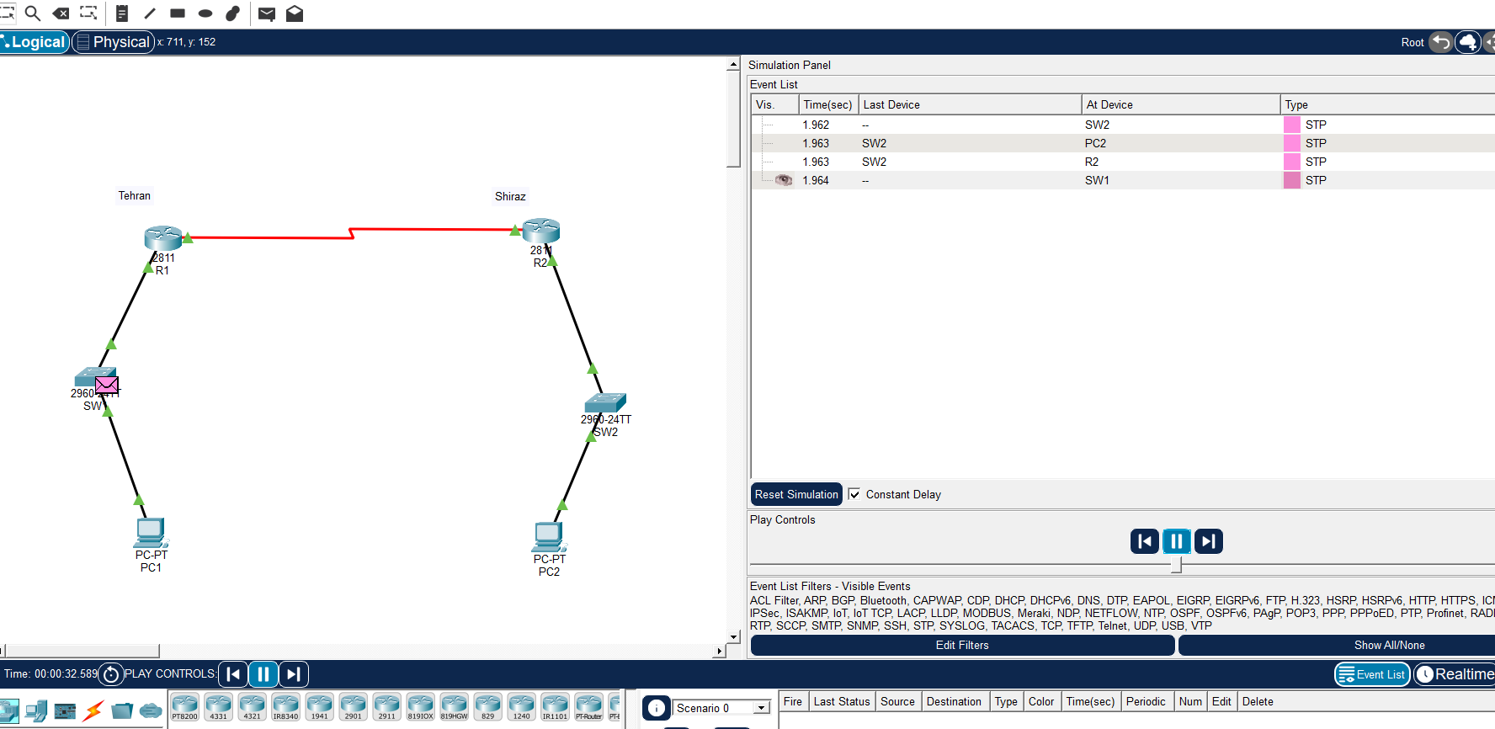

Q.2 Suppose you want to create 3 subnets of a network having network address 198.168.1.0. In another network with network address 220.168.2.0, you want to create 2 subnets. For this scenario configure the end devices and routers accordingly. Connect two different networks (both are subnetted) through static routing and show the message transmission among hosts of the two networks.

Subnet | Network ID | Usable IP Range | Broadcast
1 | 198.168.1.0/26 | .1 – .62 | .63
2 | 198.168.1.64/26 | .65 – .126 | .127
3 | 198.168.1.128/26 | .129 – .190 | .191
Subnet | Network ID | Usable IP Range | Broadcast
1 | 220.168.2.0/25 | .1 – .126 | .127
2 | 220.168.2.128/25 | .129 – .254 | .255
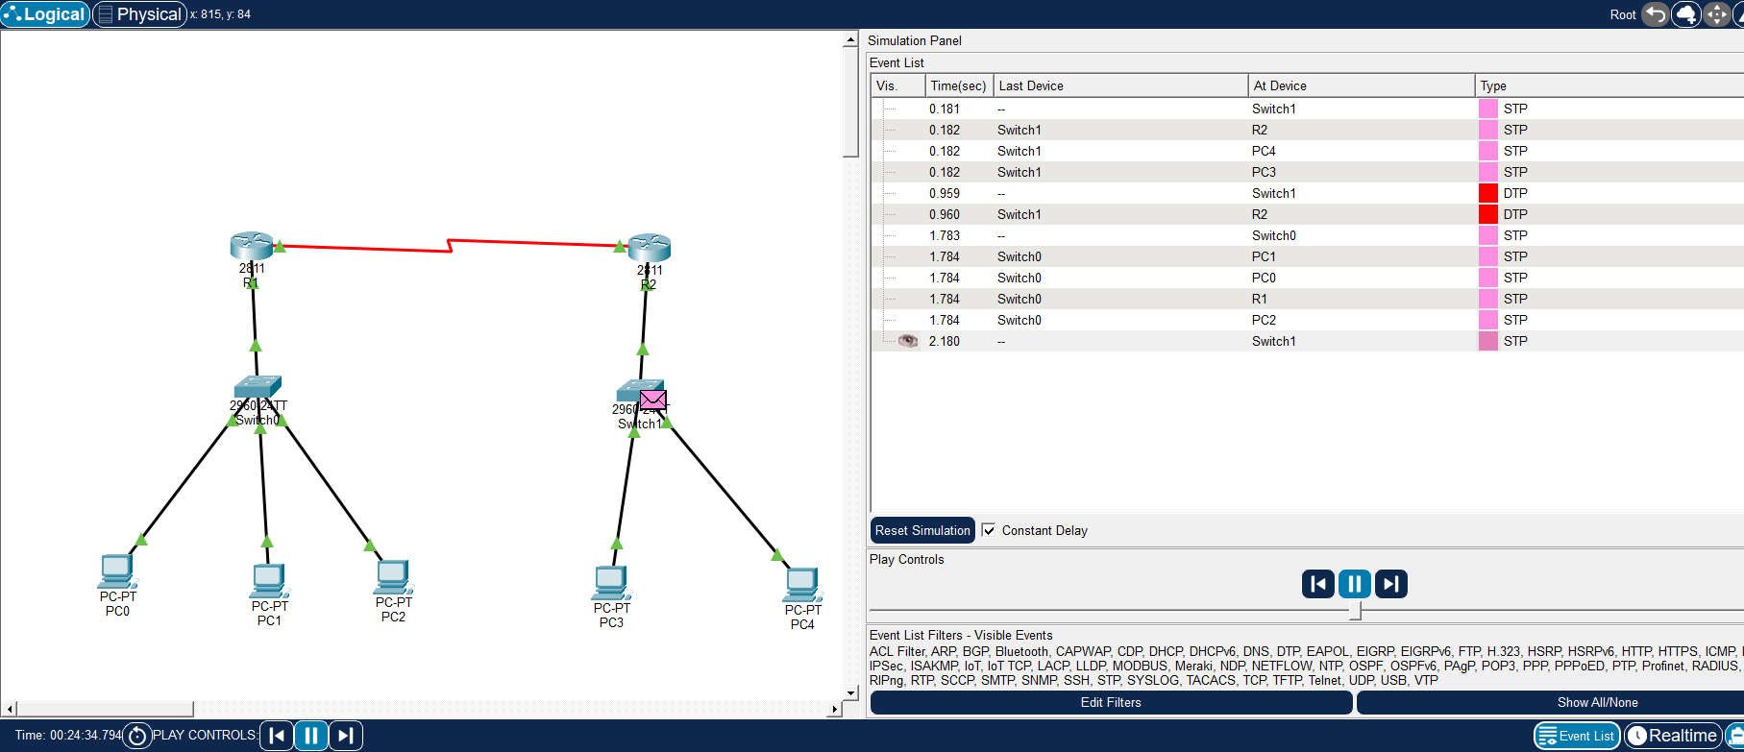

Q.3. Connect two networks having network address 192.168.3.0 and 224.152.1.0 respectively. Network 1 having 4 and network two having 3 hosts. Connect two different networks through a router. For this scenario configure the end devices and routers accordingly and show the message transmission among hosts of the two networks.

